Game Design Document

Project 44

1. Title of the game

The spider man game

1. Goal of the game

Hang on to the spider man webs and reach the highest distance u can

1. Brief story of your game.

The avengers need your help in defeating the enemy but the enemy has set up a dangerous course full of deadly obstacles, Your goal is to dodge the obstacles and move forward all the best

1. The playing characters of this game

|  |  |  |
| --- | --- | --- |
| Number | Character Name | What can this character do? |
| 1 | Spider man | He can release webs and swing |

1. Non-Playing Characters of this game

|  |  |  |
| --- | --- | --- |
| Number | Character Name | What can this character do? |
| 1 | Deadly Walls | If your hero touches the walls he dies |
| 2 | spike | If your hero touches the spike he dies |

6. Imagination of this game.

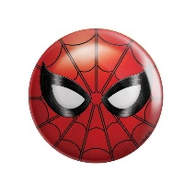 Deadly wall

Hero

Spike

7. How do you plan to make your game engaging ?

By allowing the playes to change character costumes and background and by addind some good music

8. intreasted in the game ? Want to play it ?

Here is the link to the game :

(Ctrl+click to open it)

<https://studio.code.org/projects/gamelab/GsKHm5iy6hpCcsSlcq7dDcdvWyVD3299UzVMNi9B5t8>

Hope you like the game, Thank you !!

-----------------X-----------------